**Python for Bioinformatics**

Exercise 2

**II-Title: Programs demonstrating use of Control structures**

1.     Write set of programs for demonstrating the usage of following loops and loop controls

                           i.          If

                         ii.          If-else

                       iii.          Multiple if-else

                       iv.          Building Switch-case

                         v.          While

                       vi.          For

                      vii.          For with range

                    viii.          Break

                       ix.          Continue

                         x.          Pass

2.     Accept number from user and calculate the sum of all number between 1 and given number

Algorithm:

Step 1: -Allows a user to enter the number (n) he wishes to calculate the sum and average. The program accepts user input using the [input function](https://pynative.com/python-input-function-get-user-input/).

Step 2: -Next, run loop till the entered number using the for loop and [range() function](https://pynative.com/python-range-function/).

Step 3: -Next, calculate the sum using a sum = sum + current number formula.

Step 4:-At last, after the loop ends, calculate the average using average = sum / n. n is a number entered by the user.

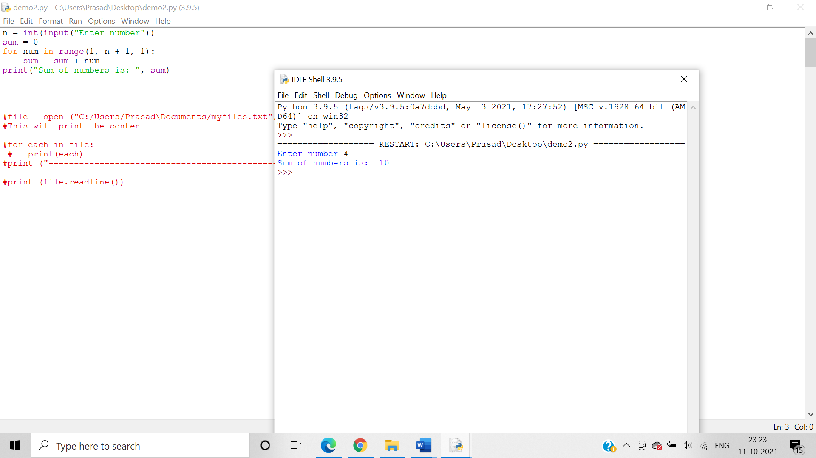

3.     Write a Python program which iterates the integers from 1 to 50. For multiples of three print "Hello" instead of the number and for the multiples of five print “Welcome". For numbers which are multiples of both three and five print "Good Morning".

4.     Write a program to check whether a number is prime or not

Algorithm:-We use a for loop to divide the input number with number ranging from 1 to input num -1 using the remainder operator % in a for loop . If the remainder is zero in any instance then the input number is divisible by other numbers and hence is not a prime number.

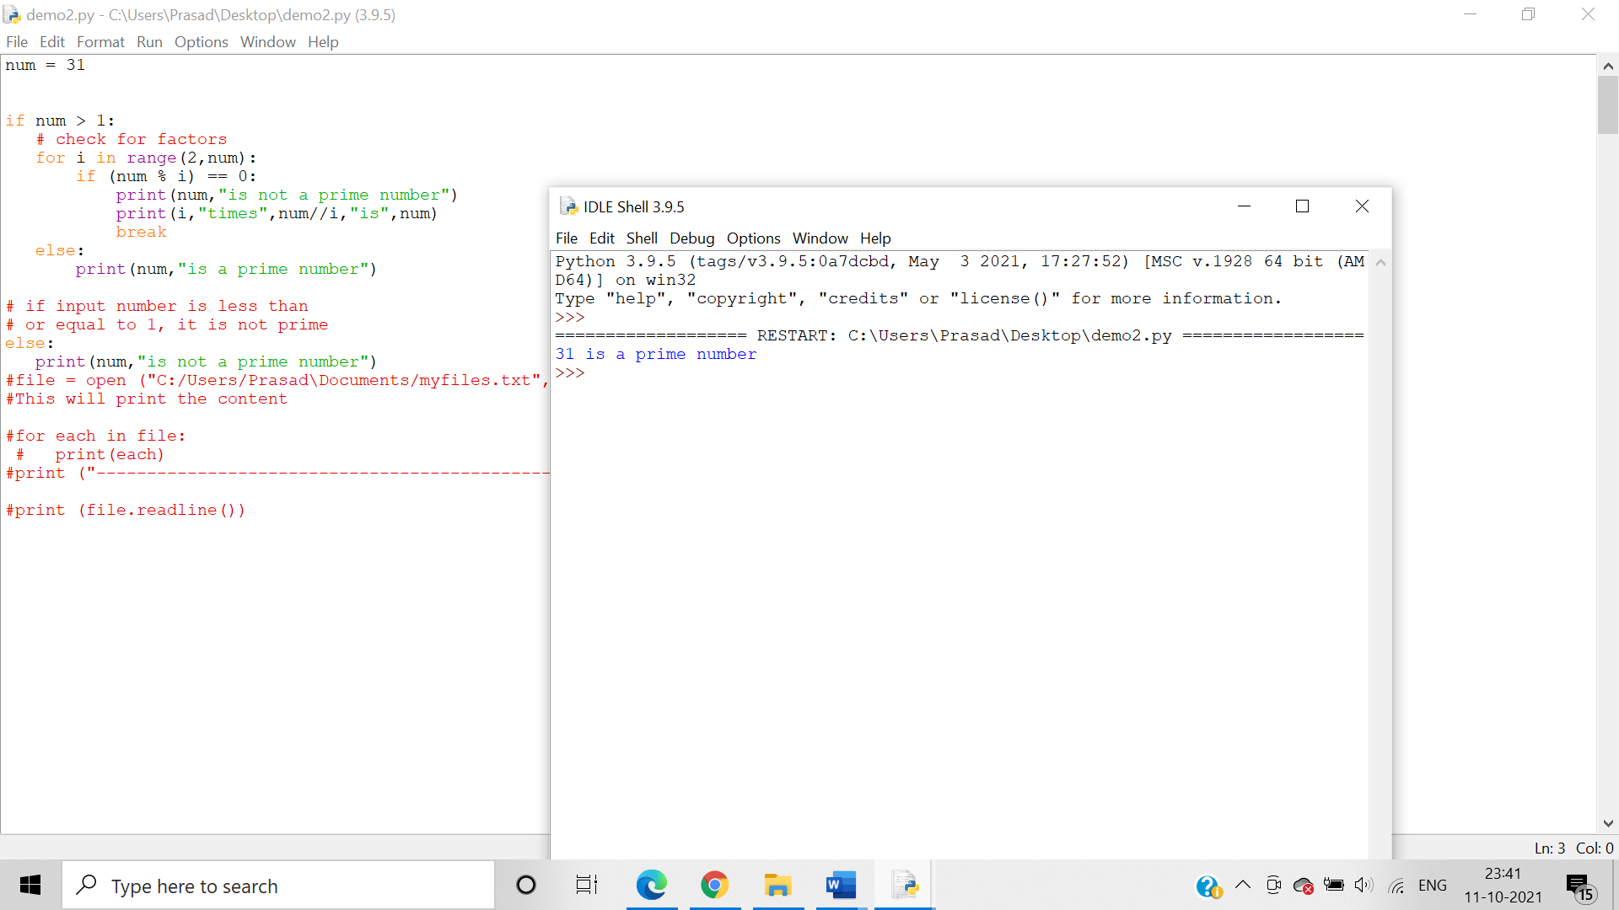

5.     Write a program to determine whether the number entered is Armstrong or not

Algorithm:-

Step 1:- The user has to enter any number.

Step 2:- Count the Number of individual digits (For Example, 370 means 3).

Step 3:- Divide the given number into individual digits (For Example, Divide 370 into 3, 7, and 0).

Step 4:- Calculate the power of n for each individual and add those numbers.

Step 5:- Compare the original value with Sum value.

Step 6:-If they exactly matched, then it is an Armstrong number else it is not Armstrong

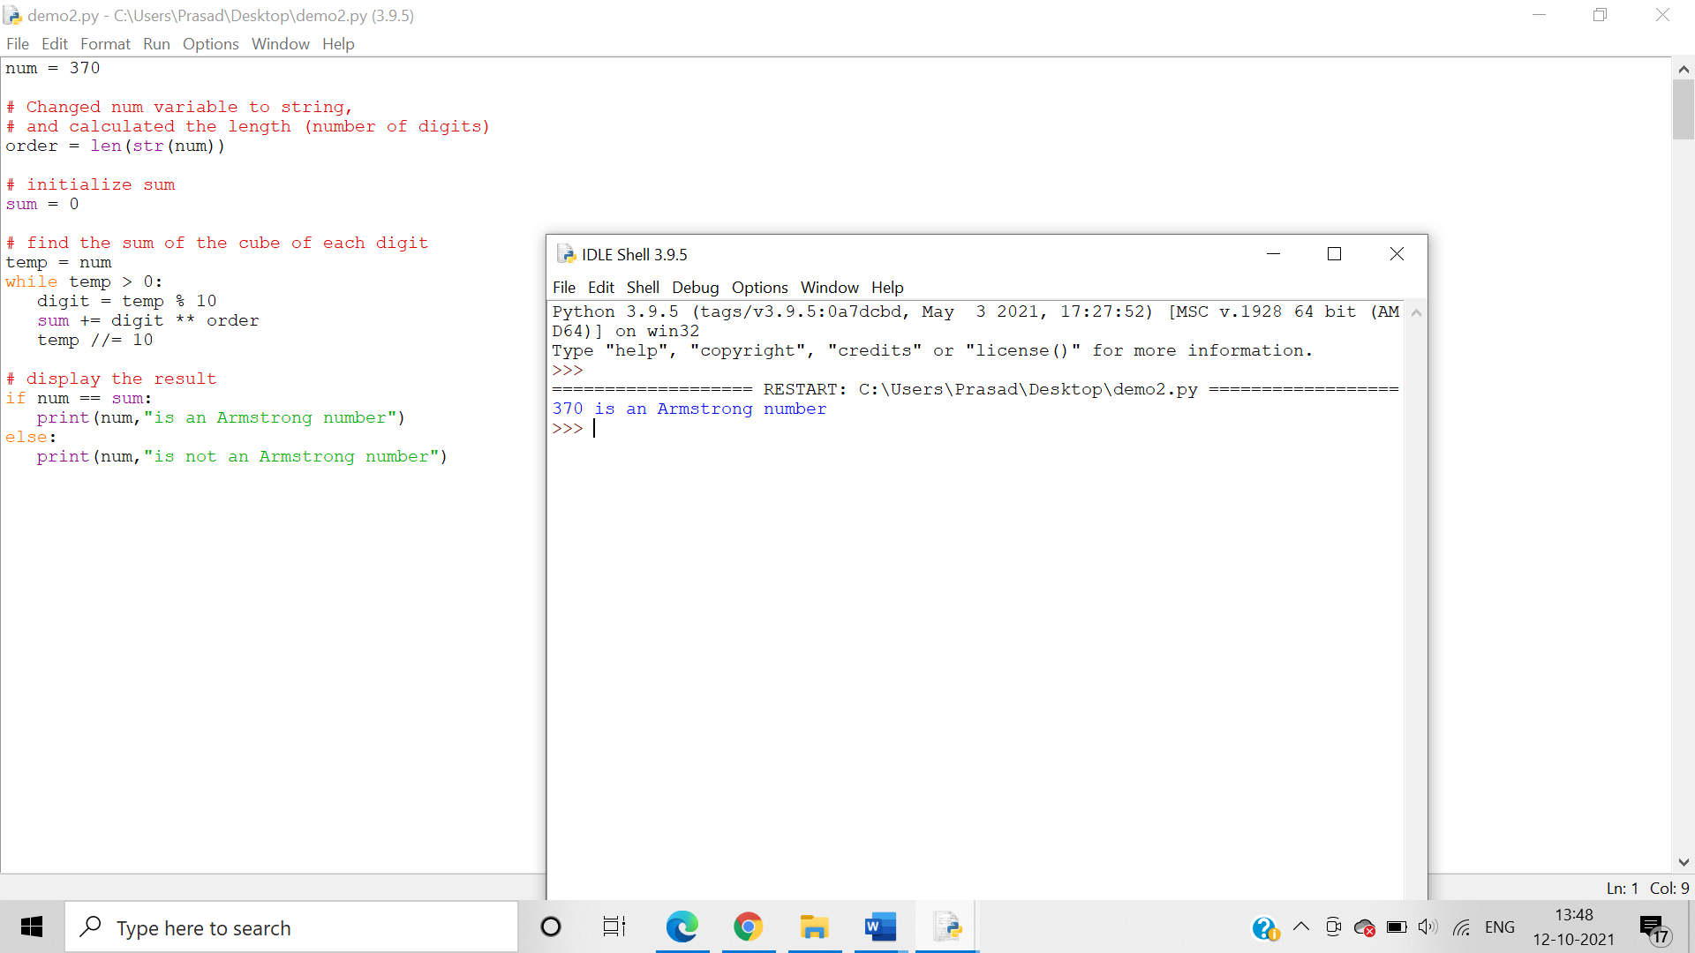

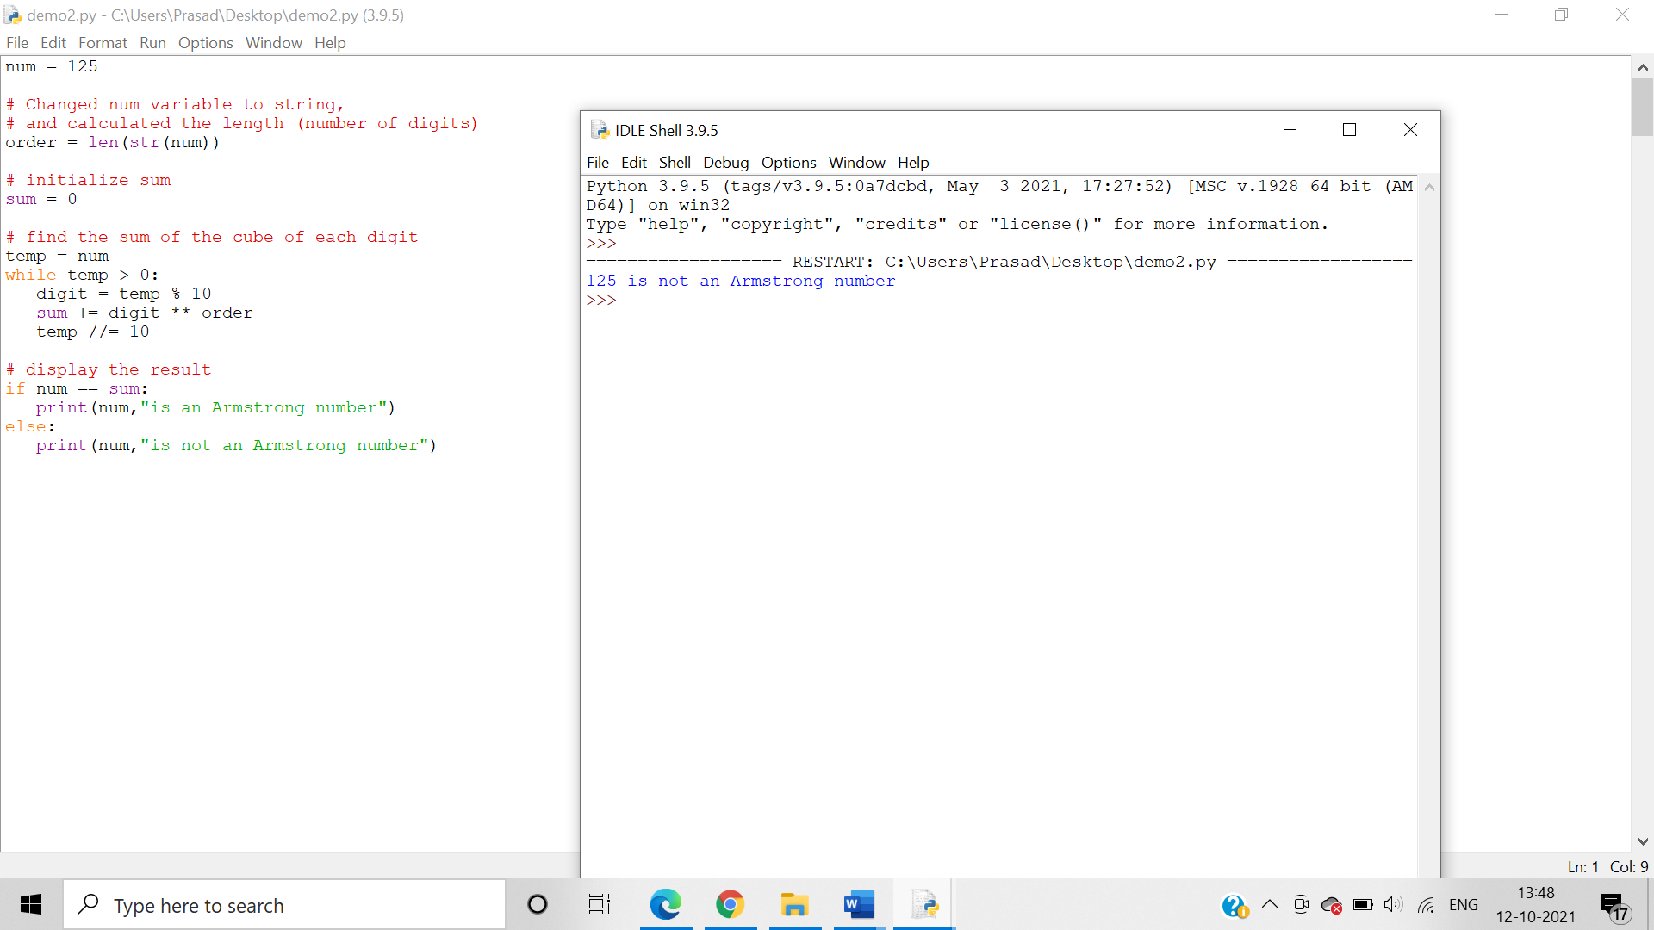

6.     Write a program to calculate the factorial of the number entered by the user

Algorithm:- We use recursive method to multiple all the number ranging from the input to 1 .

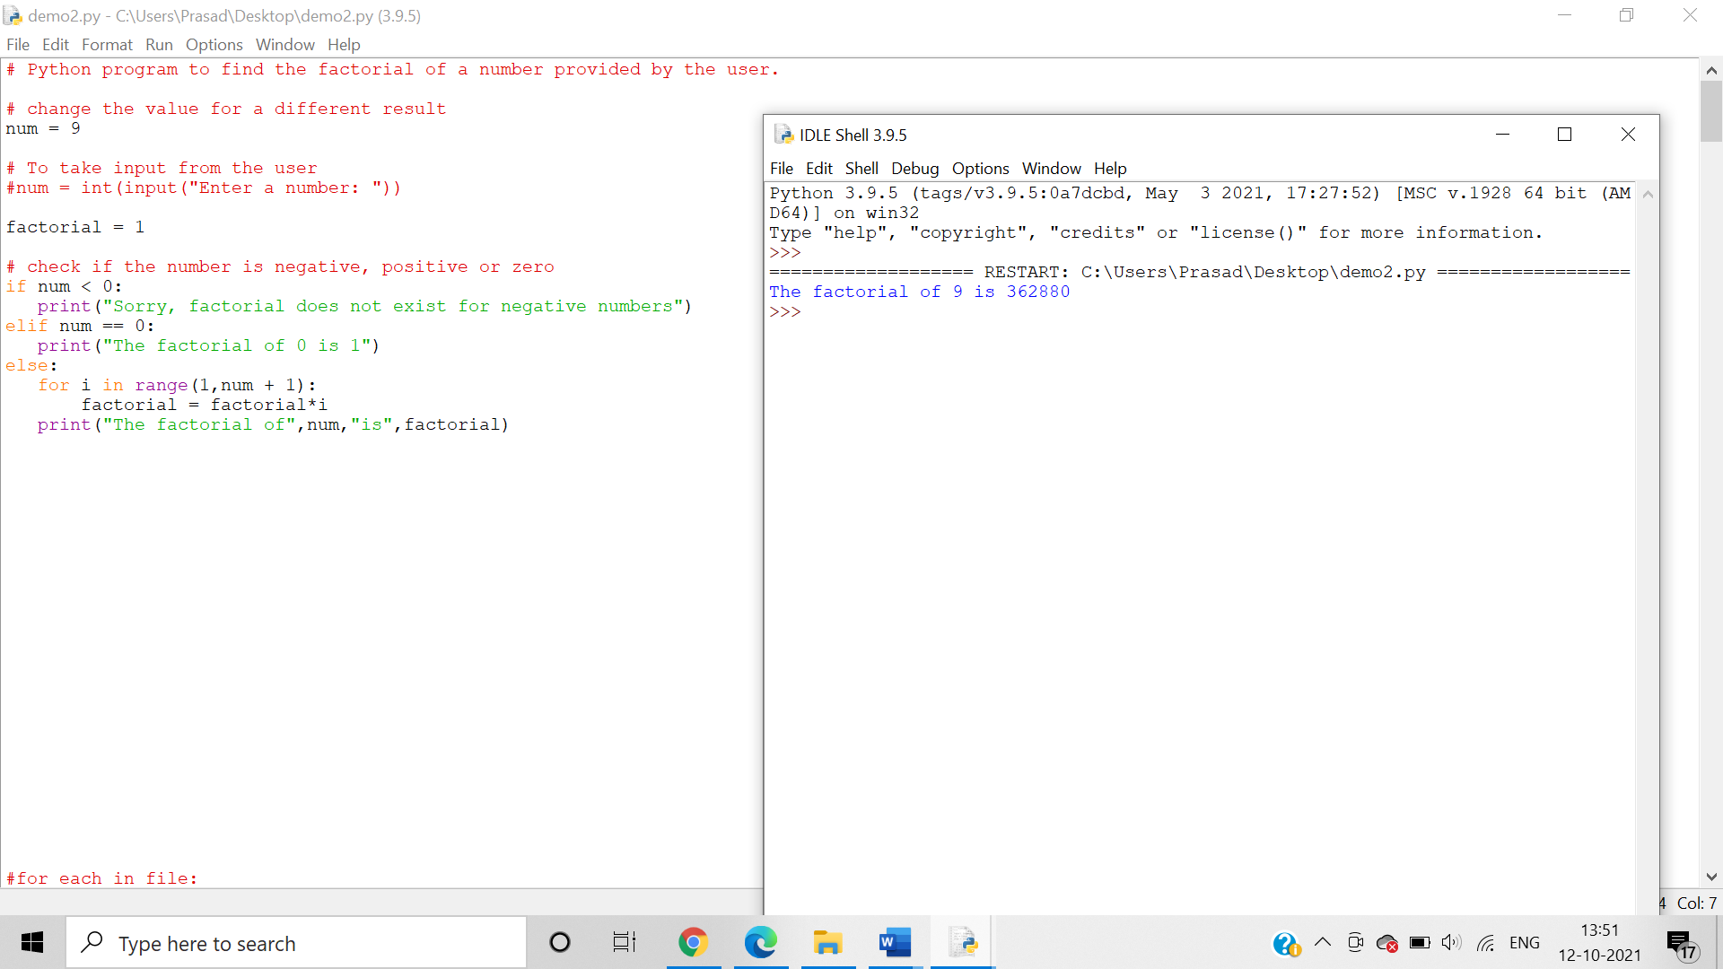

7.     Print all odd and even numbers separately entered in the user defined range

Algorithm:- A number is even if it is perfectly divisible by 2. When the number is divided by 2, we use the remainder operator % to compute the remainder. If the remainder is not zero, the number is odd.

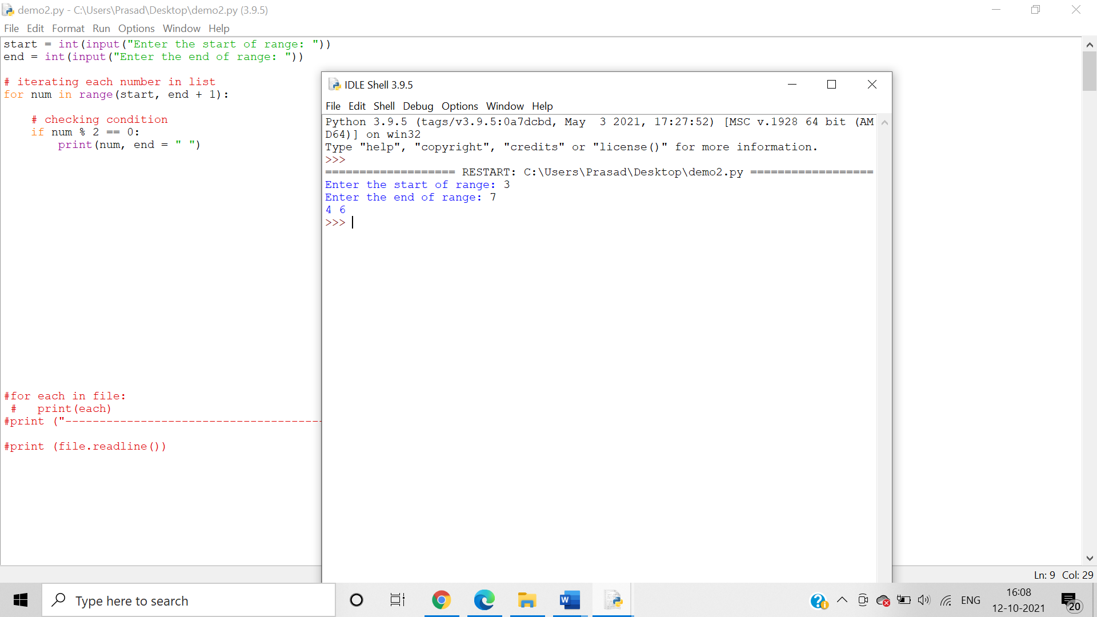

8.     Write a program to reverse words in a given String in Python

Algorithm:-

Step 1 Initialize the string.

Step 2 Split the string on space and store the resultant list in a variable called words.

Step 3 Reverse the list words using reversed function.

Step 4 Convert the result to list.

Step 5 Join the words using the join function and print it.

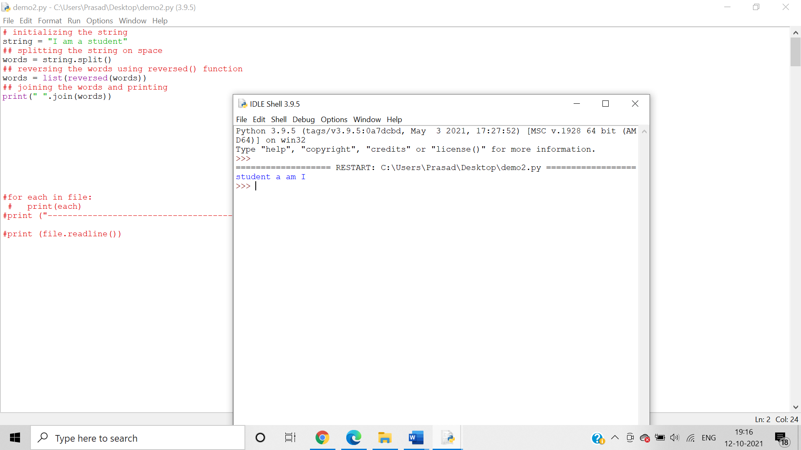

9.     Construct the following pattern, using a nested for loop.

*  
* *  
* * *  
* * * *  
* * * * *  
* * * *  
* * *  
* *  
*

Algorithm:-

Step 1:- Accept the number of rows from a user using [input()](https://pynative.com/python-input-function-get-user-input/) function or decide the size of a pattern.

Step 2:- Iterate the number of rows using outer for loop and [range() function](https://pynative.com/python-range-function/)

Step 3:- Next, the inner loop or nested for loop to handle the number of columns. Inner loop iteration depends on the values of the outer loop.

Step 4:- asterisk in a Pyramidal pattern using the print() function.

Step 5:- Add a new line after each row, i.e. after each iteration of outer for loop so you can display pattern appropriately.

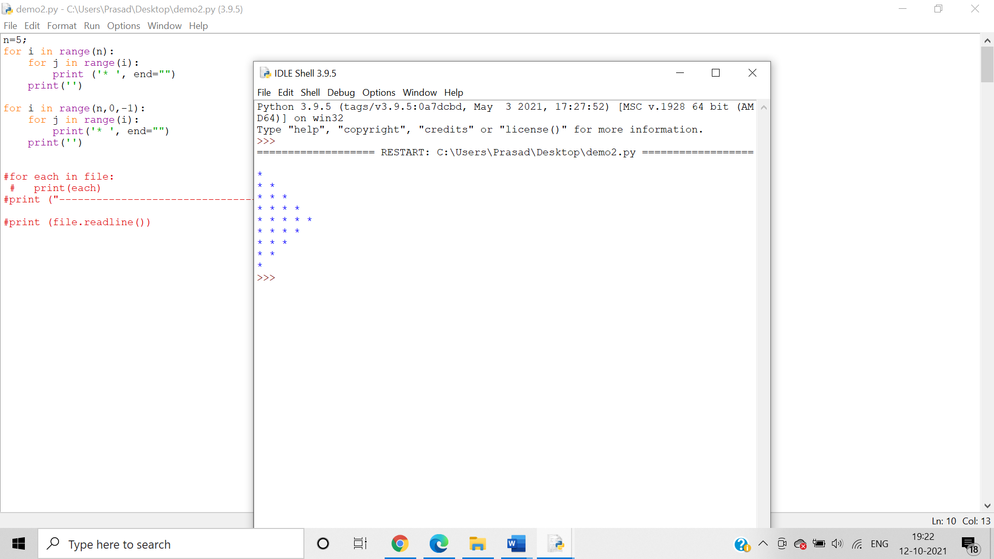

10.  Print the following pattern using for loop

5 4 3 2 1

4 3 2 1

3 2 1

2 1

1

Algorithm:-

Step 1:- Accept the number of rows from a user using [input()](https://pynative.com/python-input-function-get-user-input/) function or decide the size of a pattern.

Step 2:- Iterate the number of rows using outer for loop and [range() function](https://pynative.com/python-range-function/)

Step 3:- Next, the inner loop or nested for loop to handle the number of columns. Inner loop iteration depends on the values of the outer loop.

Step 4:- Print number using the print() function.

Step 5:- Add a new line after each row, i.e. after each iteration of outer for loop so you can display pattern appropriately.

